Nathan Rosenfeld

CSC 3750 Final Project

The following are the screenshots of the webpage. For the main page and the testimonials, in which the differences resulting from responsiveness to screensize are most apparent.I have included screeshots at several sizes. There are seven pages in all. Some of them open into a new window, others replace the main window. All use the same style sheet which is included with the code.

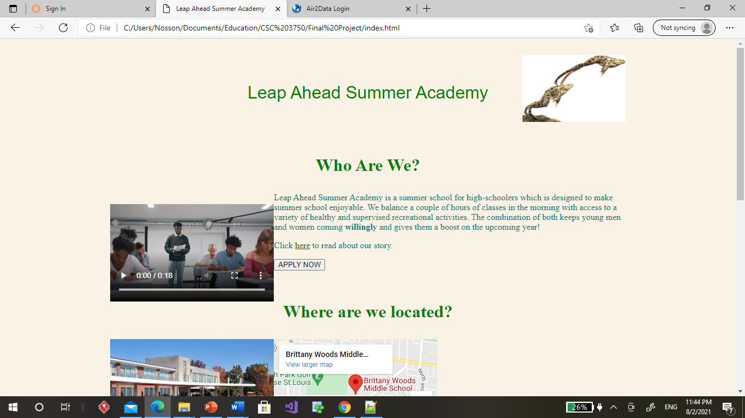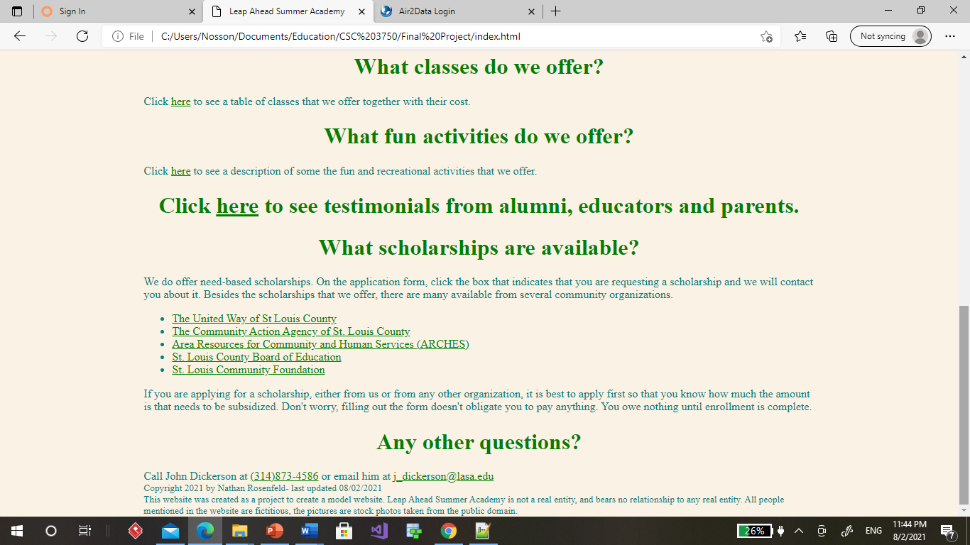Here is the main screen minimized:

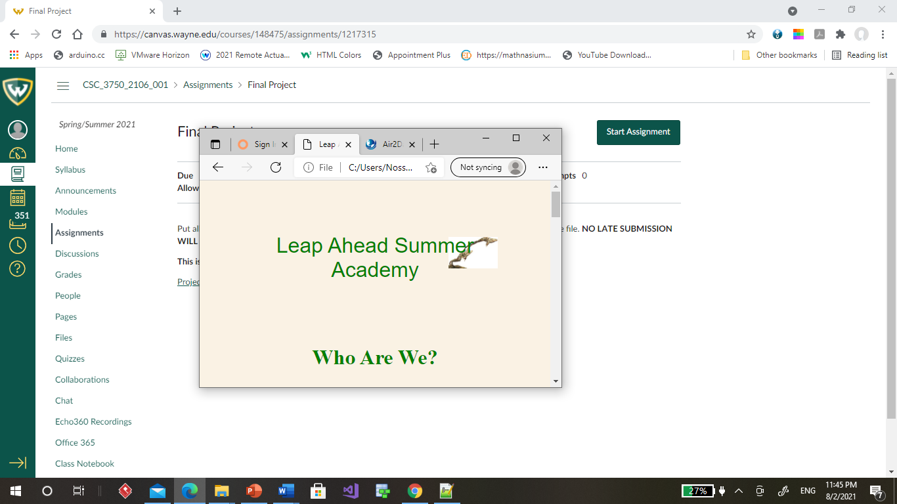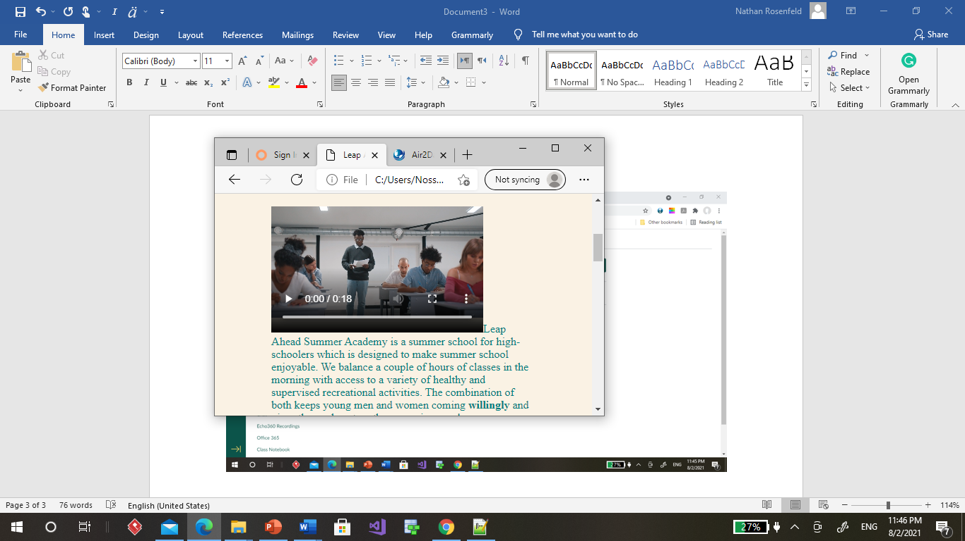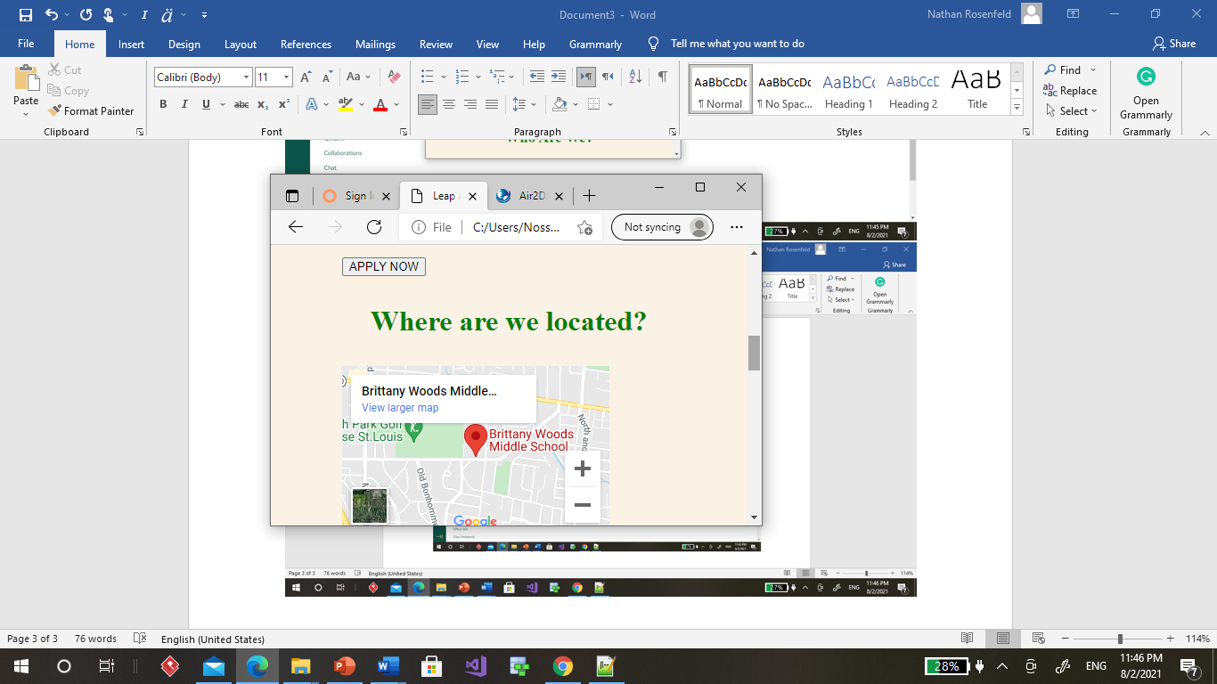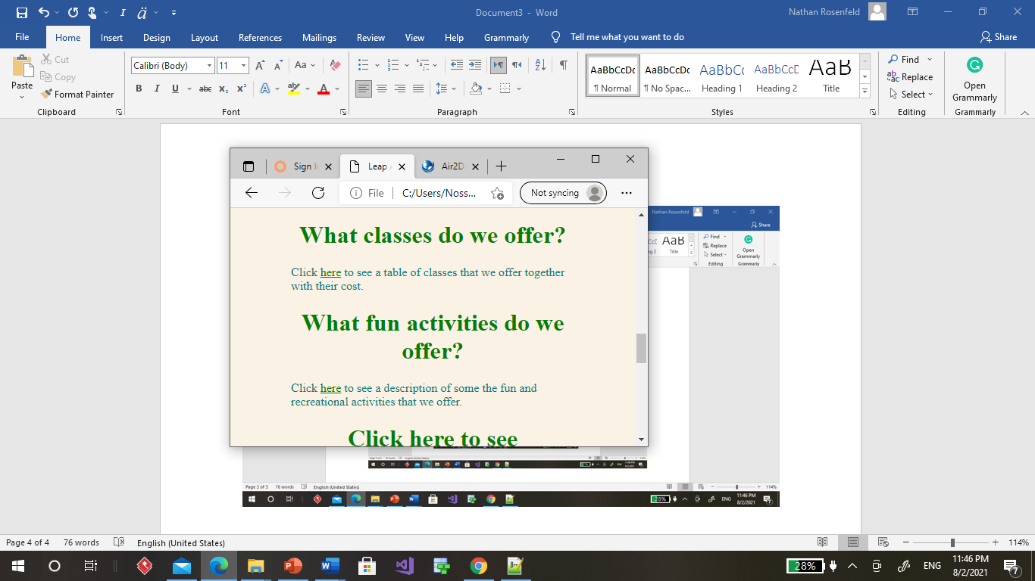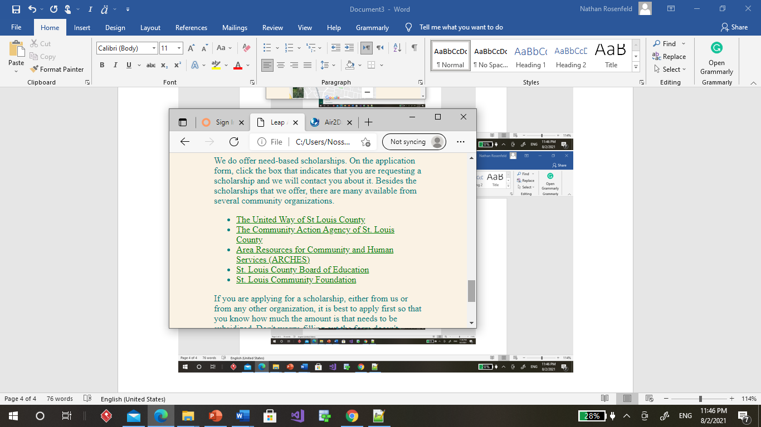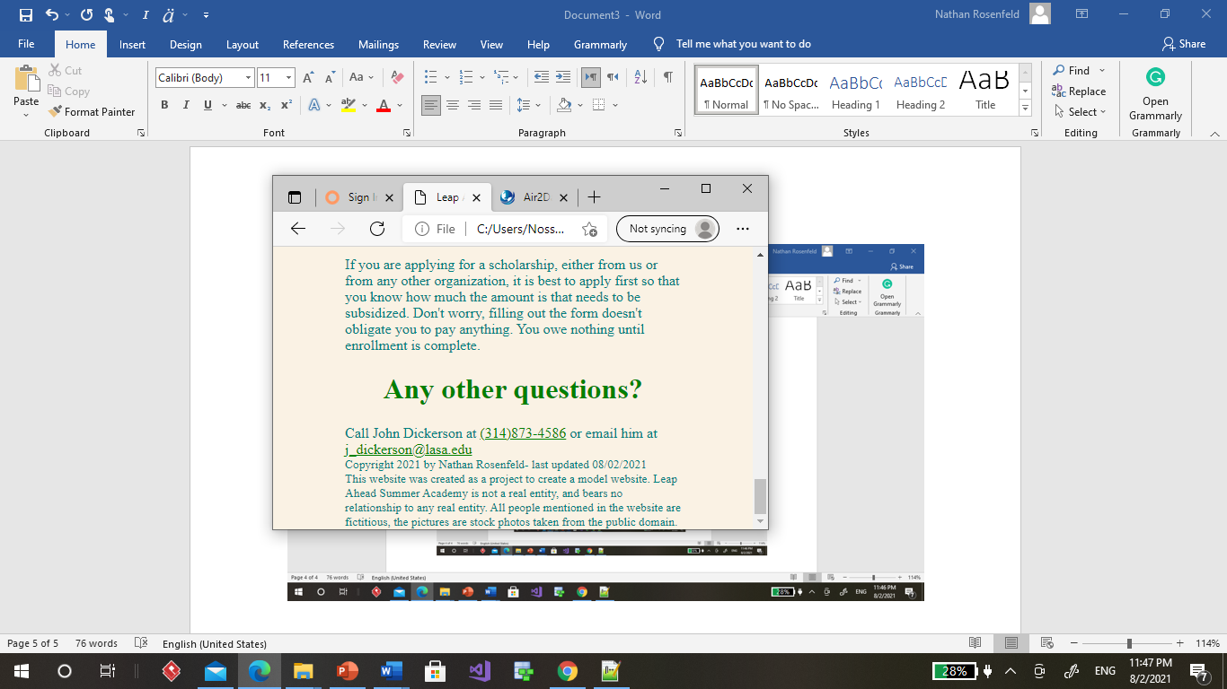

The following is the testimonials page when maximized:

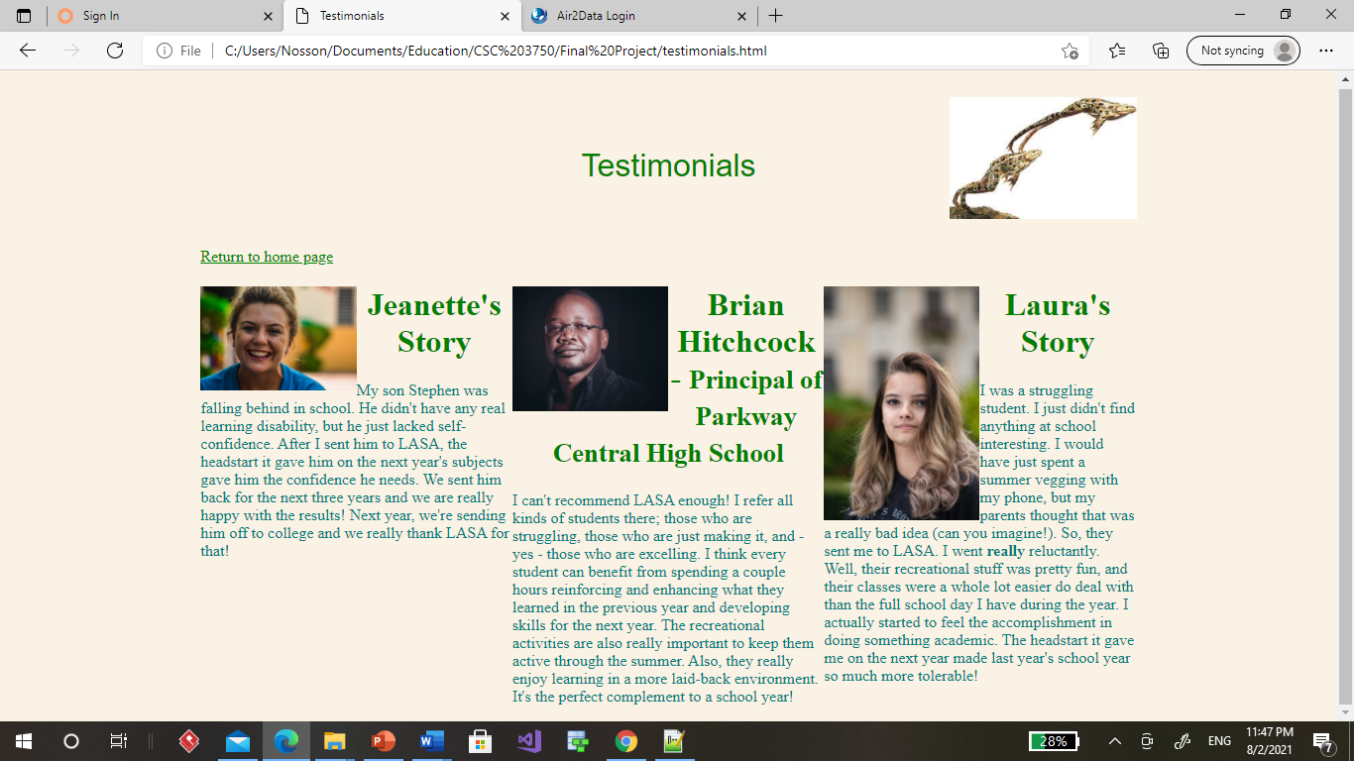In which the 3 column format is used.

Here it is minimized:

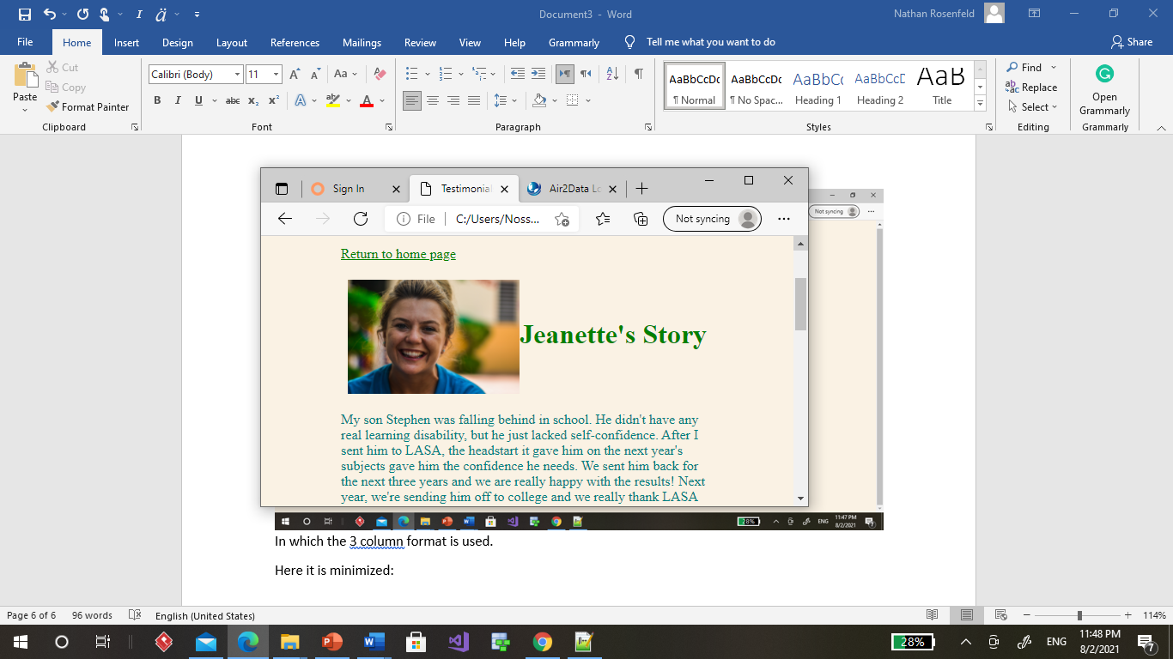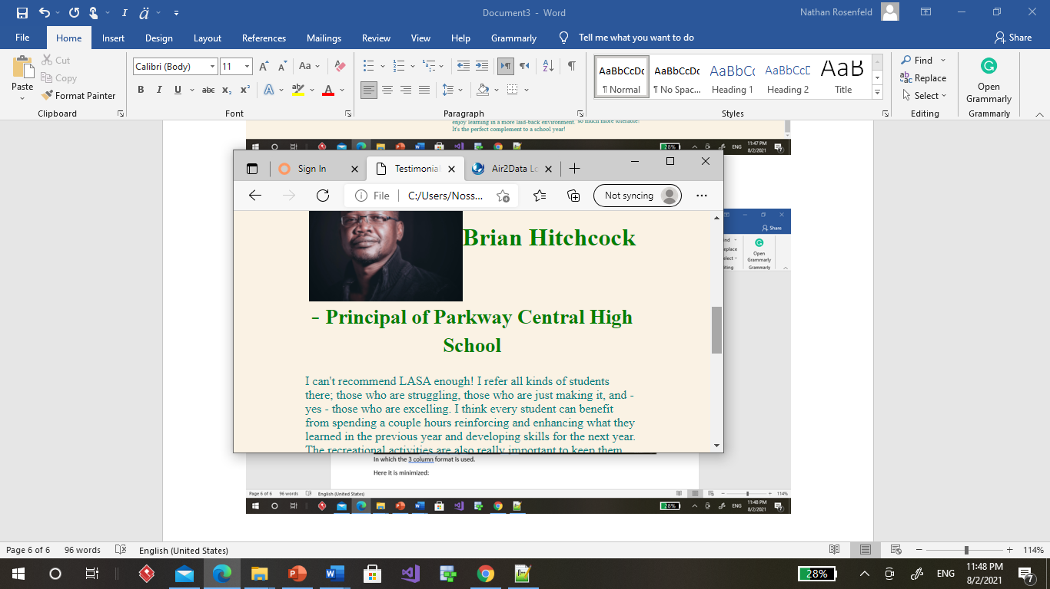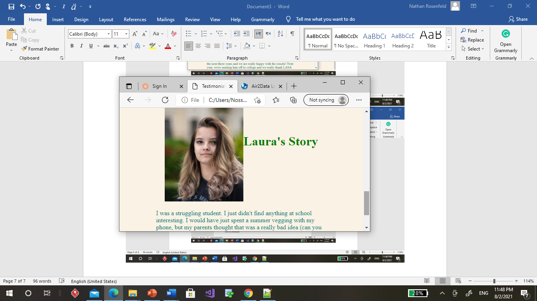

The following is the application page:

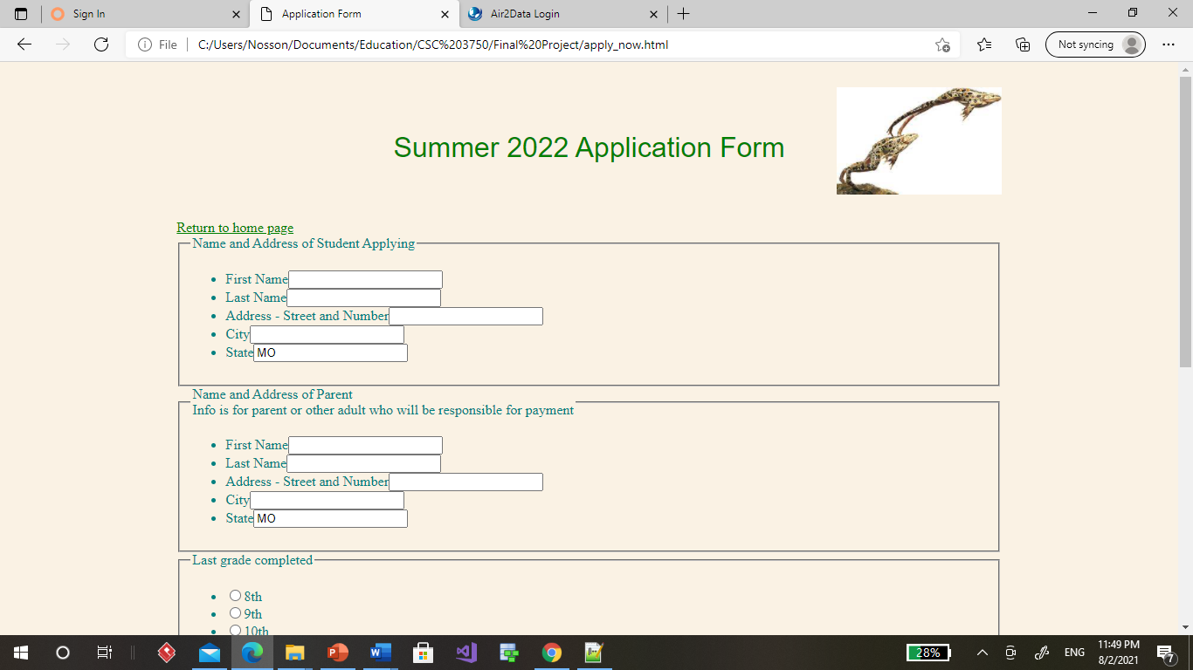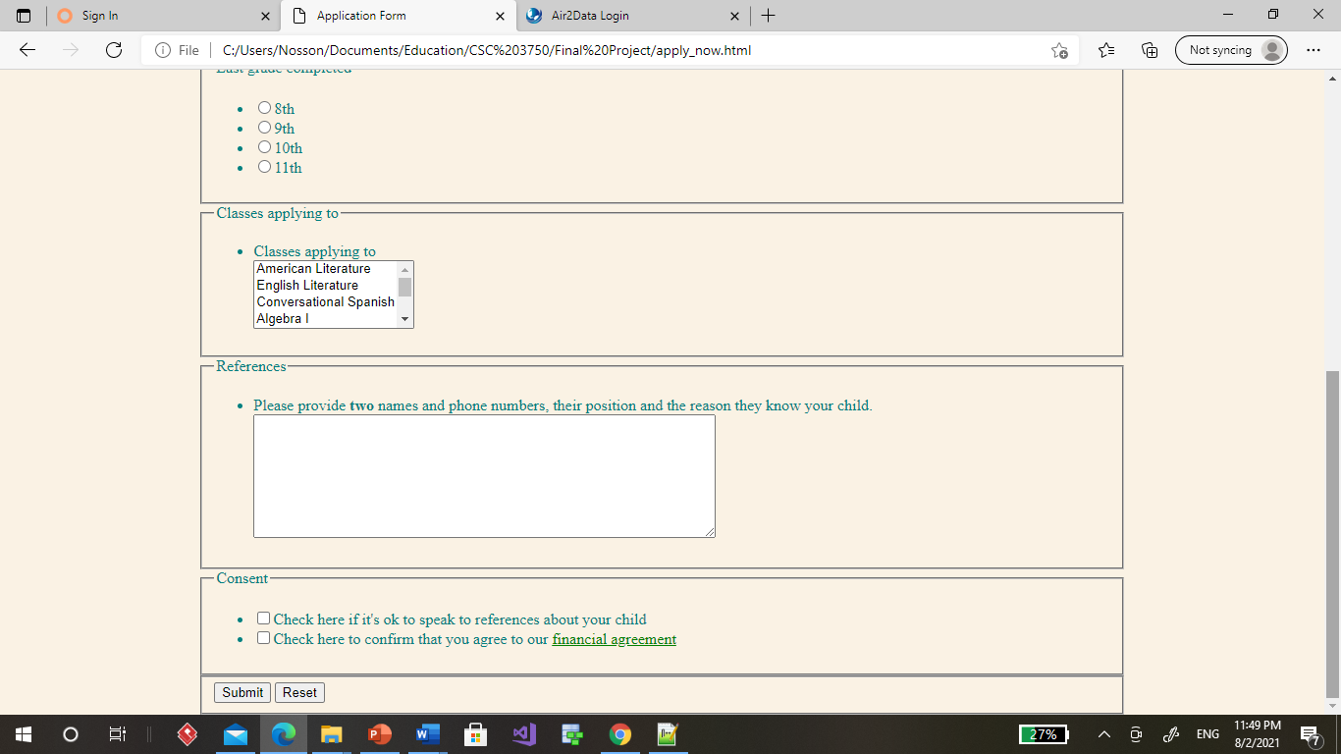The submit sends an email to me:

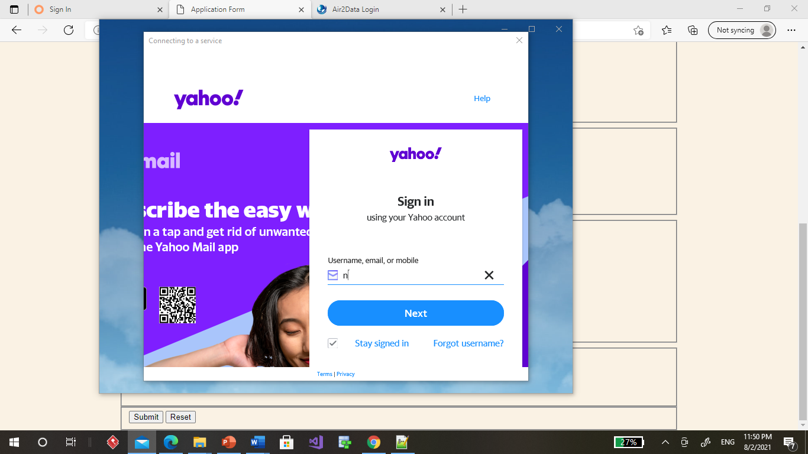

This is the financial agreement which pops up at the checkbox on the application

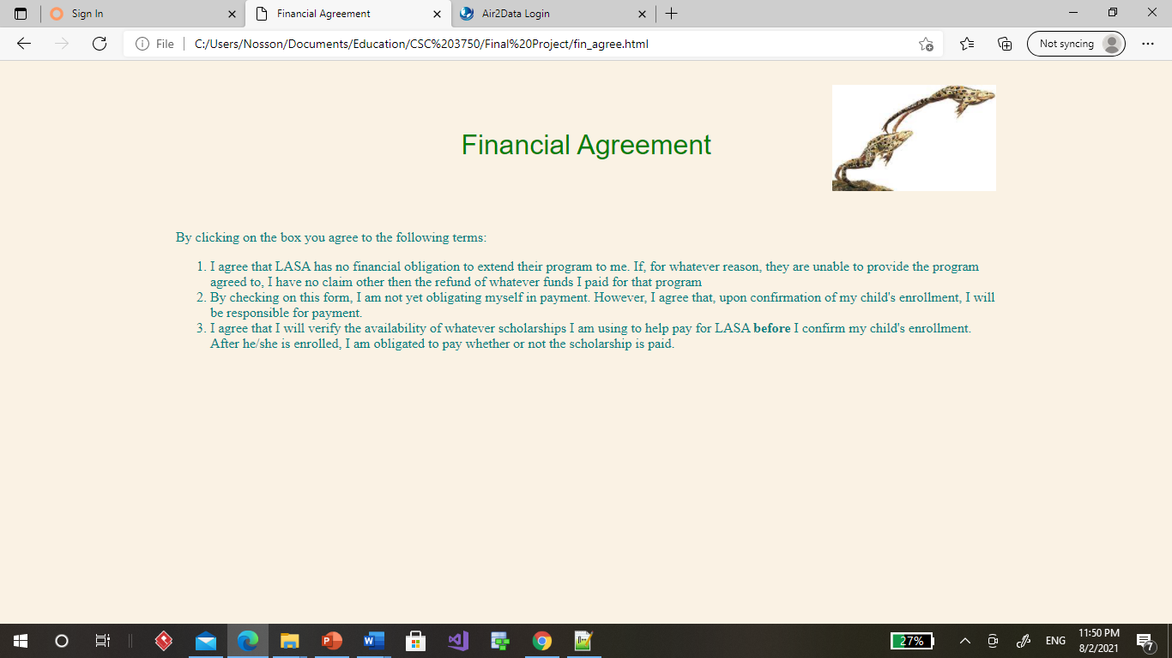Here is a table of classes offered:

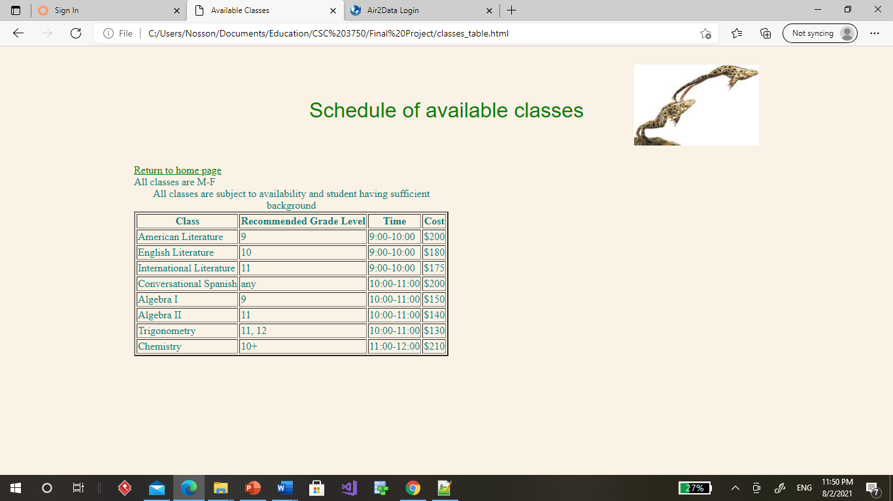

Here is a page describing activities offered:

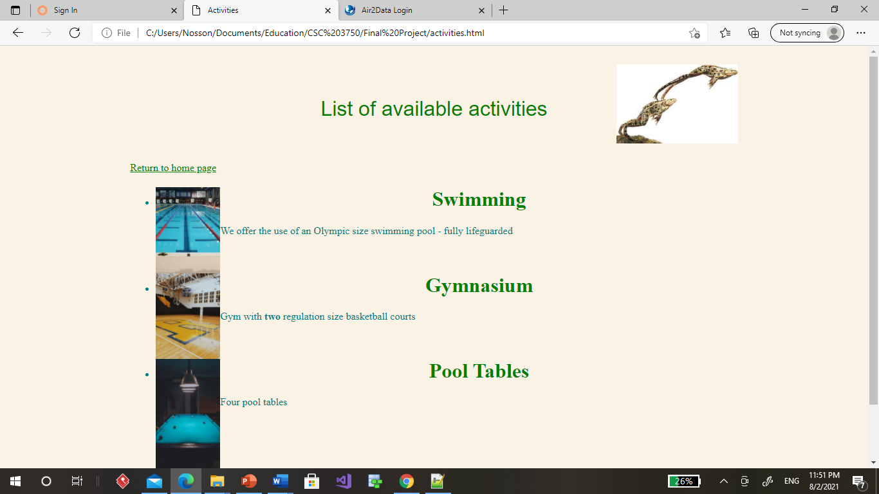

Here’s the “about us” page:

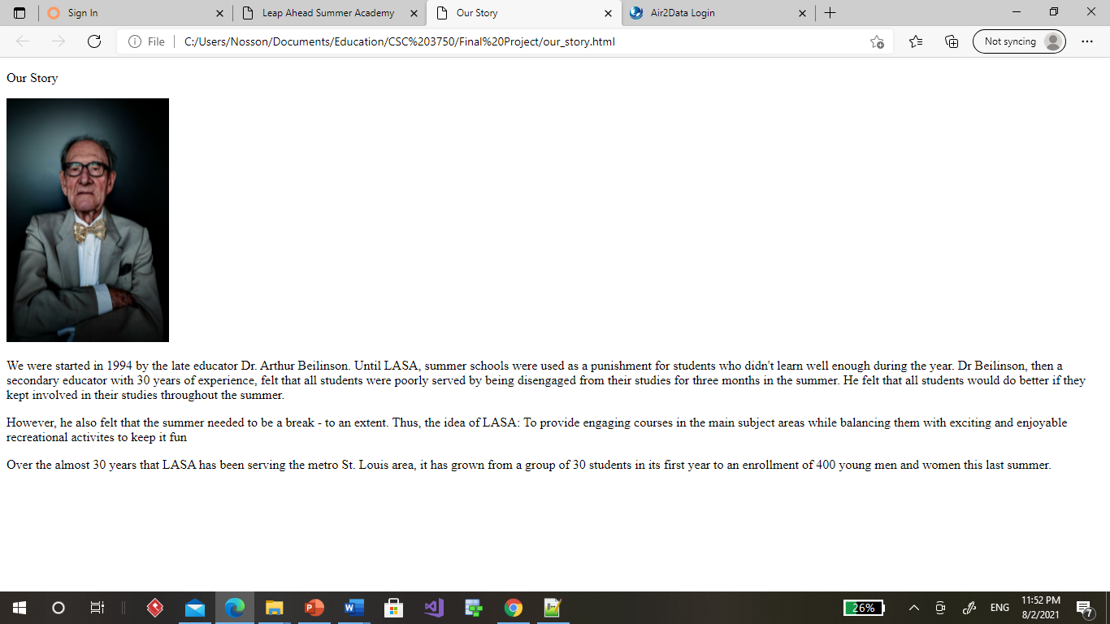

Here is a copy of the code for index.html:

<!DOCTYPE HTML5>

<html>

<meta charset="utf-8">

<head>

<style>

@import url(style_sheet_all.css)

</style>

<title>Leap Ahead Summer Academy</title>

</head>

<body>

<header>

<p><class = "cname">Leap Ahead Summer Academy</class><br>

</header>

<main>

<div id="whoAreWe">

<h1><p>Who Are We?</p></h1>

<p><video src="images/classroom.mp4" width="300" height="200" autoplay controls><img src=""></video><class id="cname">Leap Ahead Summer Academy</class> is a summer school for high-schoolers which is designed to make summer school

enjoyable. We balance a couple of hours of classes in the morning with access to a variety of healthy and supervised

recreational activities. The combination of both keeps young men and women coming <b>willingly</b> and gives them

a boost on the upcoming year!</p></div>

<div id="ourStory">

<p>Click <a href="our_story.html" target="_blank">here</a> to read about our story.</p>

<a href= "apply_now.html"><button>APPLY NOW</button></a>

<div = "whereAreWe"><h1><p>Where are we located?</p></h1>

<iframe src="https://www.google.com/maps/embed?pb=!1m14!1m8!1m3!1d6230.321731269333!2d-90.352735!3d38.6681709!3m2!1i1024!2i768!4f13.1!3m3!1m2!1s0x87df34c332fbcfa5%3A0x81890439d61bc62b!2sBrittany%20Woods%20Middle%20School!5e0!3m2!1sen!2sus!4v1627906342541!5m2!1sen!2sus" width="300" height="200" style="border:0;" allowfullscreen="" loading="lazy"></iframe>

<img src="images/pic_school.jpg" width="300" height="200"></img>

<p>We are centrally located in University City in the Brittany Woods Middle School building. </p></div>

<div = "offerings">

<h1>What classes do we offer?</h1>

<p>Click <a href="classes_table.html">here</a> to see a table of classes that we offer together with their cost.</p></div>

<div ="rec"><h1>What fun activities do we offer?</h1>

<p>Click <a href="activities.html">here</a> to see a description of some the fun and recreational activities

that we offer.</p>

</div>

<div = "testimonials"><h1>Click <a href = "testimonials.html">here</a> to see testimonials from alumni, educators and parents.</h1>

</div>

<div = "scholarships><h1>What scholarships are available?</h1>

<p>We do offer need-based scholarships. On the application form, click the box that indicates that you are requesting a scholarship and we

will contact you about it. Besides the scholarships that we offer, there are many available from several community organizations.

<ul>

<li><a href="https://mo211.myresourcedirectory.com/index.php/education">The United Way of St Louis County</a></li>

<li><a href="https://www.caastlc.org/home-2/contact-us/">The Community Action Agency of St. Louis County</a></li>

<li><a href="http://www.stlarchs.org/">Area Resources for Community and Human Services (ARCHES)</a></li>

<li><a href="https://stlouiscountymo.gov/">St. Louis County Board of Education</a></li>

<li><a href="https://stlgives.org/">St. Louis Community Foundation</a></li></ul>

If you are applying for a scholarship, either from us

or from any other organization, it is best to apply first so that you know how much the amount is that needs to be subsidized. Don't worry,

filling out the form doesn't obligate you to pay anything. You owe nothing until enrollment is complete.</a></p>

</div>

<div ="moreInfo"><h1> Any other questions?</h1>

Call John Dickerson at <a href="tel:3148734586">(314)873-4586</a> or email him at <a href="email">j_dickerson@lasa.edu</a></div>

</main>

</body>

<footer>

<small>Copyright 2021 by Nathan Rosenfeld- last updated 08/02/2021<br>This website was created as a project to create a model website. Leap Ahead Summer Academy

is not a real entity, and bears no relationship to any real entity. All people mentioned in the website are fictitious, the pictures are stock

photos taken from the public domain.</small>

</footer>

</html>

**For apply_nox.html:**

<!DOCTYPE html>

<html>

<head>

<meta charset="utf-8">

<title>Application Form</title>

</head>

<style>

@import url(style_sheet_all.css)

</style>

<header>

<p>Summer 2022 Application Form</p>

</header>

<body>

<head>

<a href="index.html">Return to home page</a>

</head>

<form action = "mailto:n_o_rosenfeld@yahoo.com" method="post" enctype="text/plain">

<fieldset>

<legend>Name and Address of Student Applying</legend>

<ul>

<li><label>First Name<input type="text" name="applicant_first_name"></label></li>

<li><label>Last Name<input type="text" name="applicant_last_name"></label></li>

<li><label>Address - Street and Number<input type="text" name="applicant_address"></label></li>

<li><label>City<input type="text" name="applicant_city"></label></li>

<li><label>State<input type="text" name="applicant_state" value="MO"></label></li>

</ul>

</fieldset>

<fieldset>

<legend>Name and Address of Parent<br>Info is for parent or other adult who will be responsible for payment</legend>

<ul>

<li><label>First Name<input type="text" name="parent_first_name"></label></li>

<li><label>Last Name<input type="text" name="parent_last_name"></label></li>

<li><label>Address - Street and Number<input type="text" name="parent_address"></label></li>

<li><label>City<input type="text" name="parent_city"></label></li>

<li><label>State<input type="text" name="parent_state" value="MO"></label></li>

</ul>

</fieldset>

<fieldset>

<legend>Last grade completed</legend>

<ul>

<li><label><input type="radio" name="grade_level">8th</label></li>

<li><label><input type="radio" name="grade_level">9th</label></li>

<li><label><input type="radio" name="grade_level">10th</label></li>

<li><label><input type="radio" name="grade_level">11th</label></li>

</ul>

</fieldset>

<fieldset>

<legend>Classes applying to</legend>

<ul><li><label for="classes_applying">Classes applying to</label></li>

<select id="classes_applying" name="classes" multiple>

<option>American Literature</option>

<option>English Literature</option>

<option>Conversational Spanish</option>

<option>Algebra I</option>

<option>Algebra II</option>

<option>Trigonometry</option>

<option>Chemistry</option></select></ul>

</fieldset>

<fieldset>

<legend>References</legend>

<ul>

<li><label for="references">Please provide <b>two</b> names and phone numbers, their position and the reason they know your child.</label></li>

<textarea id="references" name="references" rows="8" cols="64"></textarea></ul>

</fieldset>

<fieldset>

<legend>Consent</legend>

<ul>

<li><input type="checkbox" name="ok_to_call_references"><label>Check here if it's ok to speak to references about your child</label></li>

<li><input type="checkbox" name="consent_to_agreement form"><label>Check here to confirm that you agree to our <a href="fin_agree.html">financial agreement </a></label></li>

</ul>

</fieldset>

<fieldset>

<input type="submit" name="Submit">

<input type="reset" value="Reset">

</fieldset>

</form>

</body>

</html>

**For classes_table.html**

<!DOCTYPE html>

<html>

<head>

<meta charset="utf-8">

<title>Available Classes</title>

</head>

<style>

@import url(style_sheet_all.css)

</style>

<header>

<p>Schedule of available classes</p>

</header>

<body>

<head>

<a href="index.html">Return to home page</a>

</head>

<main>

<table border="2">

<caption>All classes are subject to availability and student having sufficient background</option>

<tr><th>Class</th><th>Recommended Grade Level</th><th>Time</th><th>Cost</th>

<tr><td>American Literature</td><td>9</td><td>9:00-10:00</td><td>$200</td></tr>

<tr><td>English Literature</td><td>10</td><td>9:00-10:00</td><td>$180</td></tr>

<tr><td>International Literature</td><td>11</td><td>9:00-10:00</td><td>$175</td></tr>

<tr><td>Conversational Spanish</td><td>any</td><td>10:00-11:00</td><td>$200</td></tr>

<tr><td>Algebra I</td><td>9</td><td>10:00-11:00</td><td>$150</td></tr>

<tr><td>Algebra II</td><td>11</td><td>10:00-11:00</td><td>$140</td></tr>

<tr><td>Trigonometry</td><td>11, 12</td><td>10:00-11:00</td><td>$130</td></tr>

<tr><td>Chemistry</td><td>10+</td><td>11:00-12:00</td><td>$210</td></tr>

<tfoot>All classes are M-F</tfoot>

</table>

</main>

</body>

</html>

**Activities.html**

<!DOCTYPE html>

<html>

<head>

<meta charset="utf-8">

<title>Activities</title>

</head>

<style>

@import url(style_sheet_all.css)

</style>

<header>

<p>List of available activities</p>

</header>

<body>

<head>

<a href="index.html">Return to home page</a>

</head>

<main>

<ul>

<li><h1>Swimming<img src="images/swimming_pool.jpg" width="100" height="100"></img></h1>

<p>We offer the use of an Olympic size swimming pool - fully lifeguarded</p>

</li>

<li><h1>Gymnasium<img src="images/basketball_court.jpg" width="100" height="100"></img></h1>

<p>Gym with <b>two</b> regulation size basketball courts</p></li>

<li><h1>Pool Tables<img src="images/pool_table.jpg" width="100" height="100"></img></h1>

<p>Four pool tables</p>

</li>

<li><h1>Workout room<img src="images/workout_room.jpg" width="100" height="100"></img></h1>

<p>Workout room with several treadmills, rowing machines, and all weightlifting equipment</p>

</li>

</ul>

</main>

</body>

</html>

**Testimonials.html**

<!DOCTYPE html>

<html>

<head>

<meta charset="utf-8">

<title>Testimonials</title>

</head>

<style>

@import url(style_sheet_all.css)

</style>

<header>

<p>Testimonials</p>

</header>

<body>

<head>

<a href="index.html">Return to home page</a>

</head>

<main>

<div class="column"><h1><img src="images/jeanette_pic.jpg" width="200" height="200"></img>Jeanette's Story</h1>

<p>My son Stephen was falling behind in school. He didn't have any real learning disability, but he just lacked self-confidence. After I sent

him to LASA, the headstart it gave him on the next year's subjects gave him the confidence he needs. We sent him back for the next three years

and we are really happy with the results! Next year, we're sending him off to college and we really thank LASA for that!</p></div>

<div class="column"><h1><img src="images/brian_pic.jpg" width="200" height="200"></img>Brian Hitchcock - <small>Principal of Parkway Central High School</small></h1>

<p>I can't recommend LASA enough! I refer all kinds of students there; those who are struggling, those who are just making it, and - yes - those

who are excelling. I think every student can benefit from spending a couple hours reinforcing and enhancing what they

learned in the previous year and developing skills for the next year. The recreational activities are also really important to keep them active

through the summer. Also, they really enjoy learning in a more laid-back environment. It's the perfect complement to a school year!

</p></div>

<div class="column"><h1><img src="images/laura_pic.jpg" width="200" height="200">Laura's Story</h1>

<p>I was a struggling student. I just didn't find anything at school interesting. I would have just spent a summer vegging with my phone, but my parents

thought that was a really bad idea (can you imagine!). So, they sent me to LASA. I went <b>really</b> reluctantly. Well, their recreational stuff

was pretty fun, and their classes were a whole lot easier do deal with than the full school day I have during the year. I actually started to feel

the accomplishment in doing something academic. The headstart it gave me on the next year made last year's school year so much more tolerable!

</p></div>

</main>

</html>

**Our_story.html**

<!DOCTYPE html>

<html>

<head>

<meta charset="utf-8">

<title>Our Story</title>

</head>

<style>

@import url(style_sheet_all.css)

@import url(style_sheet_all.css)

</style>

<header>

<p>Our Story</p>

</header>

<body>

<head>

</head>

<main>

<img src="images/dr_beilinson.jpg" width="200px" height="300px">

<p>We were started in 1994 by the late educator Dr. Arthur Beilinson. Until <span class="abbrName"><abbr>LASA</abbr></class>, summer schools were used as a

punishment for students who didn't learn well enough during the year. Dr Beilinson, then a secondary educator with 30 years of

experience, felt that all students were poorly served by being disengaged from their studies for three months in the summer. He felt that all

students would do better if they kept involved in their studies throughout the summer.</p>

<p>However, he also felt that the summer needed to be a break - to an extent. Thus, the idea of <span class = "abbrName"><abbr>LASA</abbr></class>:

To provide engaging courses in the main subject areas while balancing them with exciting and enjoyable recreational activites to keep it fun</p>

<p>Over the almost 30 years that <span class ="abbrName">LASA<abbr></abbr></class> has been serving the metro St. Louis area, it has grown

from a group of 30 students in its first year to an enrollment of 400 young men and women this last summer.</p>

</main>

</body>

</html>

**Fin_agree.html**

<!DOCTYPE html>

<html>

<head>

<meta charset="utf-8">

<title>Financial Agreement</title>

</head>

<style>

@import url(style_sheet_all.css)

</style>

<header>

<p>Financial Agreement</p>

</header>

<body>

<main>

<p>By clicking on the box you agree to the following terms:

<ol>

<li>I agree that LASA has no financial obligation to extend their program to me. If, for whatever reason, they are unable

to provide the program agreed to, I have no claim other then the refund of whatever funds I paid for that program</li>

<li>By checking on this form, I am not yet obligating myself in payment. However, I agree that, upon confirmation of my child's enrollment, I will

be responsible for payment.</li>

<li>I agree that I will verify the availability of whatever scholarships I am using to help pay for LASA <b>before</b> I confirm my child's

enrollment. After he/she is enrolled, I am obligated to pay whether or not the scholarship is paid.</li>

</ol>

</main>

</body>

</html>

**Style_sheet_all.css**

body {

background-color: #faf2e4;

margin: 0 15%;

font-family:Arial, sans=serif;

color:teal;

}

header{

margin-top:1;

padding: 3em 1em 2em 1em;

text-align:center;

text-style:bold;

color: green;

background: url(images/frog.jpg);

background-position: center right;

background-repeat: no-repeat;

background-size: 20%;

}

header p{

font-family:Arial, sans-serif;

font-size:2em;

}

img{

max-width: 50%;

height:auto;

vertical-align:middle;

}

h1{

text-align: center;

text-style:bold;

color:green;

clear:left;

vertical-align:middle;

}

a{

color:green;

}

@media screen and (min-width: 700px){

img{

float: left;

}

video{

float:left;

}

}

@media screen and (min-width: 940px){

.column{

float:left;

width: 33.3%;

}

}

This website was patterned after the one I did throughout the semester for Charlies car service and the textbook’ one for Blue Goose Bistro. Also, I had in mind the plethora of websites I’ve interacted with in muy life.

The target audience is pretty self-explanatory. It is concerned parents trying to help their children.

I hope I reach them effectively.